Muhammad Hammad(24k0544) CN LAB 1 TASK(A)

Tasks
(Only attach a screenshot of the command prompt/terminal for every question.)

- Find the IP address of the computer you are using and the IP address version.
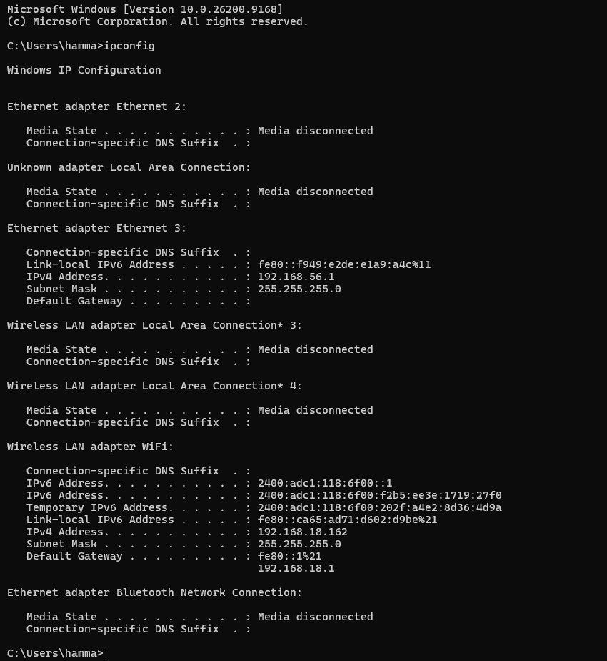
Command: ipconfig
IP Address: 192.168.18.162
IP Address version: IPv4
- Find the subnet mask of the computer you currently use, MAC address, the gateway, and whether DHCP is turned on.
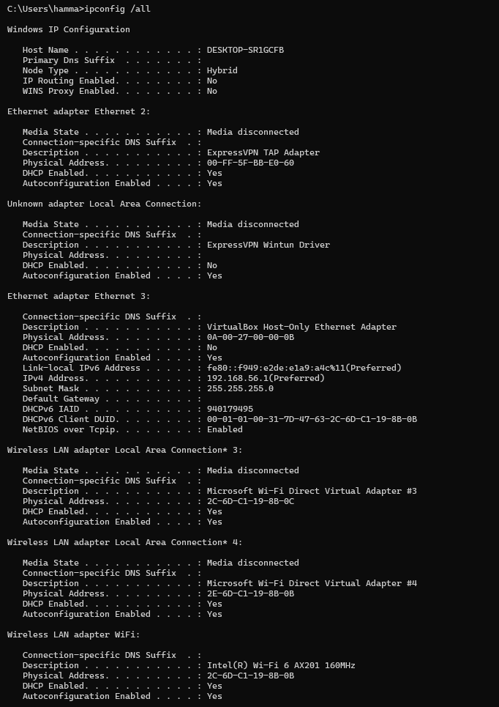
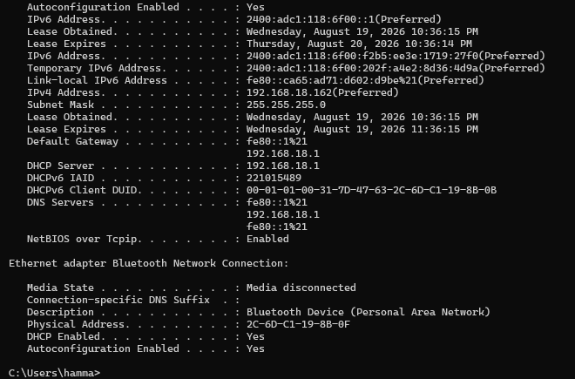
Command: ipconfig /all
Subnet Mask: 255.255.255.0, MAC address: 2C-6D-C1-19-8B-0F, gateway: 192.168.18.1, DHCP status: Enabled
- Display the hostname of the computer and which protocol needs to be installed to access this command.
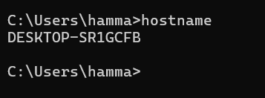
Command: hostname
Hostname: DESKTOP-SR1GCFB
Protocol Name: DNS needed to be installed

- By which command do we check basic IP connectivity between two computers, check the connectivity with any other computer, and state the reason whether it's connected or not?
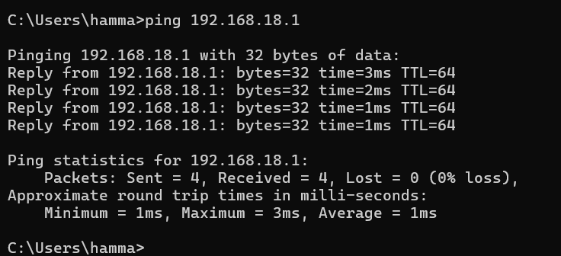
Command: ping 192.168.18.1
Reason: All 4 packets were send and received with 0% loss so the computer is reachable.

- Find out which ports on your host are connected to applications. Connect the browser to some external web page before running the appropriate command.
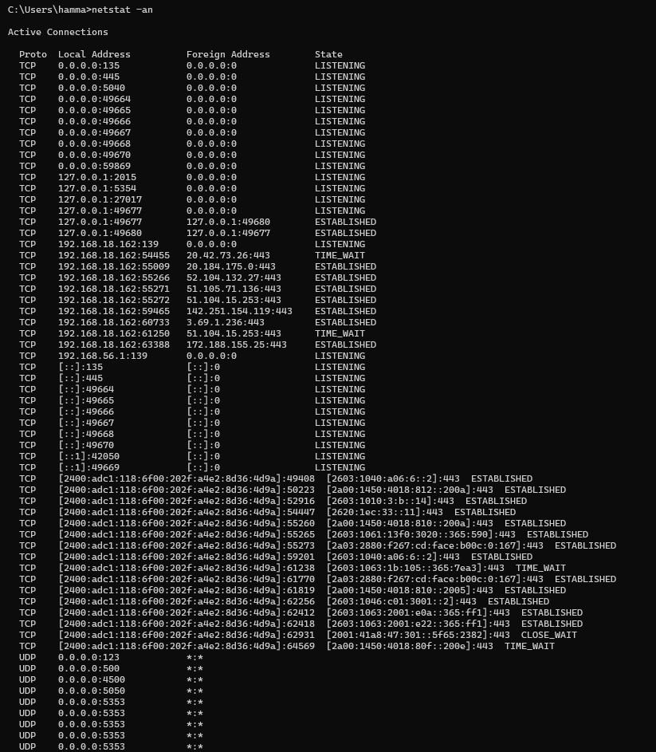
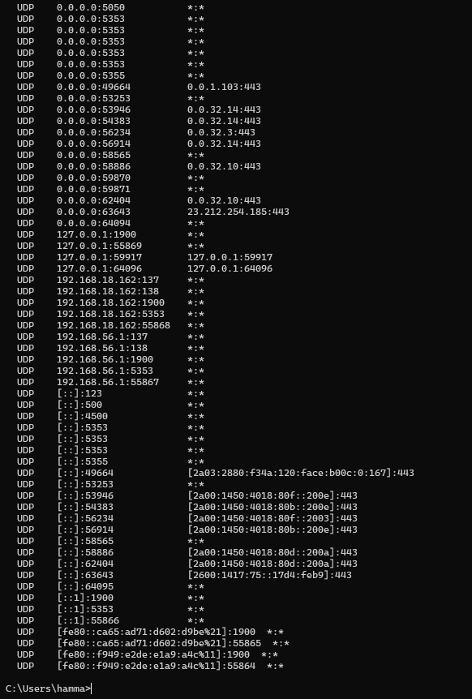
Command: netstat -an
Reason: To display active network connections, including the local/remote ports, connection status, and process ID of the applications using those connections.

- Find the path of routers to at least three websites(of your own choice). What is its IP address? How many hops are involved in the path?
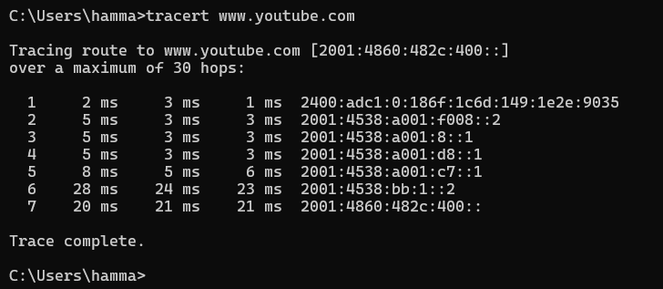
Command: tracert www.youtube.com

- A ping to 8.8.4.4 works but a ping to the machine’s name “Syrin machine” fails. What could be wrong? Write reason in concise form (1 to 2 sentences).

Reason:
The DNS/name resolution is not working correctly, so the computer cannot translate “Syrin machine” into an IP address

- If the order of the wires on both ends of the RJ45 connector is the same, which type of cable is used?

Answer: Straight-through cable

- Can you connect a Router Ethernet port to the PC NIC using a straight-through cable?(Yes or No) Answer: YES
- Can you connect a Switch to a PC or server using a crossover cable?(Yes or No) Answer: NO
- Can you connect a Hub to a PC or server using a straight-through cable?(Yes or No) Answer: YES

- Find all other hosts available on the network.
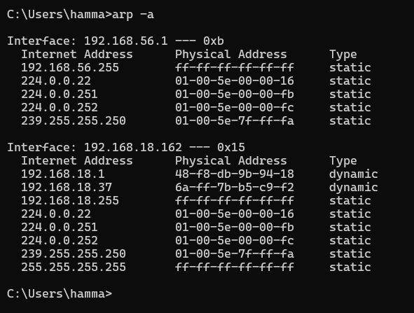

Command: arp -a

- Check any port on TCP and show the results.
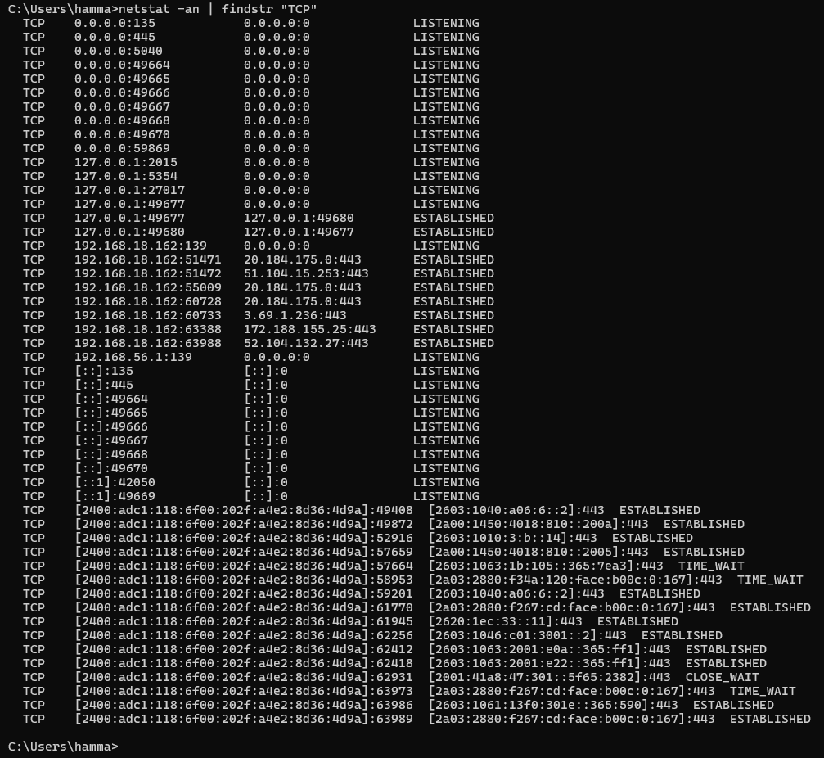

Command: netstat -an | findstr “TCP”

- Display the number of datagrams sent and received.
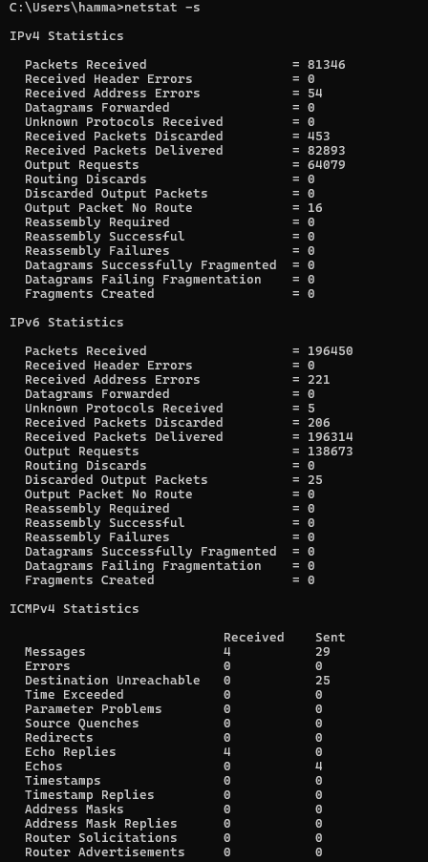

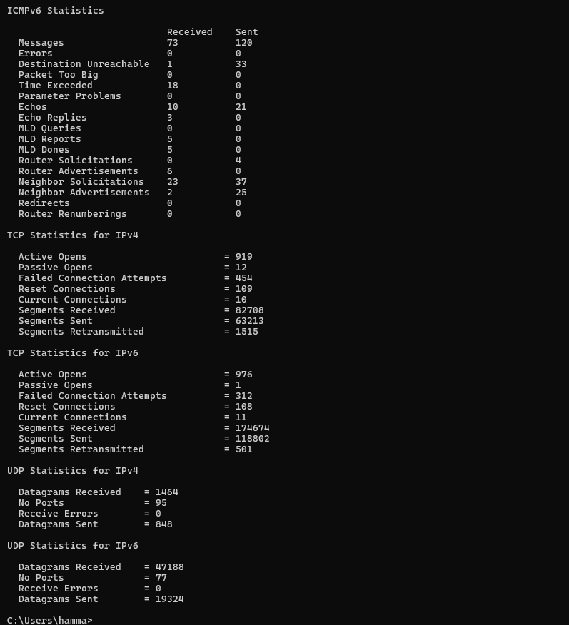

Command: netstat -s

